# LAB 1: Packet Tracer

**Course Outcomes: Objectives**

Upon completion of this lab, you will be able to:

CO1 Implement the basic concept and architecture of computer network.

# Background

Many network problems can be fixed at the Physical layer of a network. For this reason, it is important to have a clear understanding of which cables to use for your network connections.

At the Physical layer (Layer 1) of the OSI model, end devices must be connected by media (cables). The type of media required depends on the type of device being connected. In the basic portion of this lab, straight–through or crossover cables will be used to connect the two workstations.

In addition, the two communicated devices must have an address. The Network layer (Layer 3) requires a unique address (also known as a logical address or IP Addresses), which allows the data to reach the appropriate destination device. Addressing for this lab will be applied to the workstations and will be used to enable communication between the devices.

# Scenario

This lab aims to form the simplest networking (peer-to-peer) that compose of two directly connected computers.

# Task 1: Create a Peer-to-Peer Network

**Step 1: Connect two workstations to create a peer-to-peer network as shown in diagram below.**

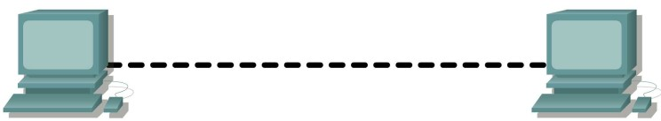

Before the devices can be cabled, you will need to identify the types of media you will be using. (Check the type of cable whether it is a crossover or straight-through). Then both end points of the cable must be connected to the devices NIC Ethernet cards.

Which cable did you use?

# Step 2: Apply a Layer 3 address to the workstations

To complete this task, you will need to follow the step-by-step instructions below.

**Note:** These steps must be completed on *each* workstation (device).

1. Double click on PC0, choose Desktop Tab and choose the IP Configuration

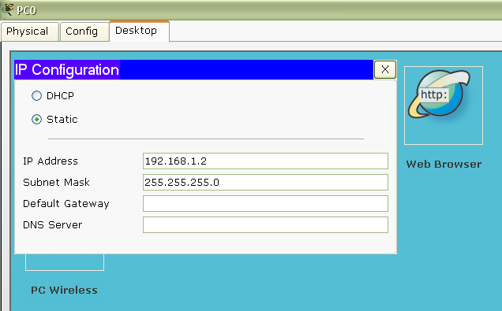

1. In the **IP address** box, enter the IP address 192.168.1.2 for PC0
2. Press the tab key and the Subnet mask is automatically entered. The subnet address should be
3. 255.255.255.0. If this address is not automatically entered, enter this address manually.
4. Click **OK**.
5. Repeat step 1 – 5 for PC1 and give the IP address for PC2 as 192.168.1.3. Subnet mask should be 255.255.255.0
6. Close the IP Connection window

# Step 3: Verify connectivity

1. On PC0, open the Host Command Line.

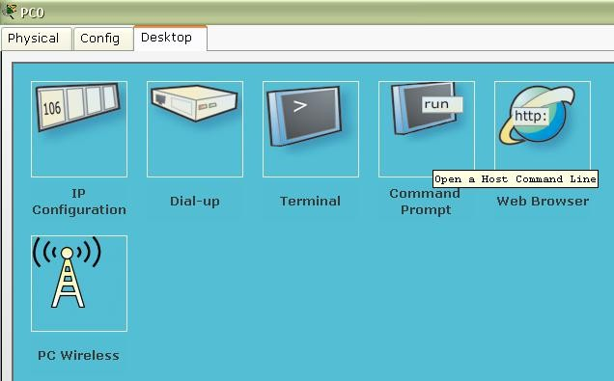

2- Type Ping (space) the IP address of the 2nd host and press the carriage return.

3- Write a report for the simple steps you have done and the result of your verification.

